**How to setup project:**

**Note: This project is in flutter(v3.0.1) stable channel do not run on other channel you maybe face issue.**

This project after extracting Codes folder. You can do this step for both platforms windows and macos:

**Step 1:**

First you need to install flutter framework in you mac / windows / Linux system.

This like is provide official flutter website: <https://flutter.dev/docs/get-started/install>

**Step 2:**

If you are first time in flutter then create test project and try command you terminal/git etc..

Command type : Flutter create testapp then enter key after few second you will see the test project, you just open this project in VSCode, Android Sudio etc.. just run the project.

**Step 3:**

If you not face any issue then you ready to run my project. Even if you face any issue then you can comment on envato so I can reply to as soon as.

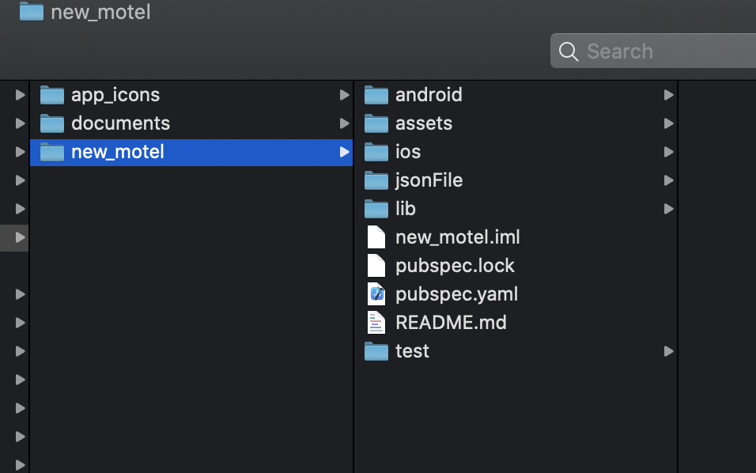

You can got this folders from envato you just open this new_motel in VScode editor.

Then your editor looks like this.

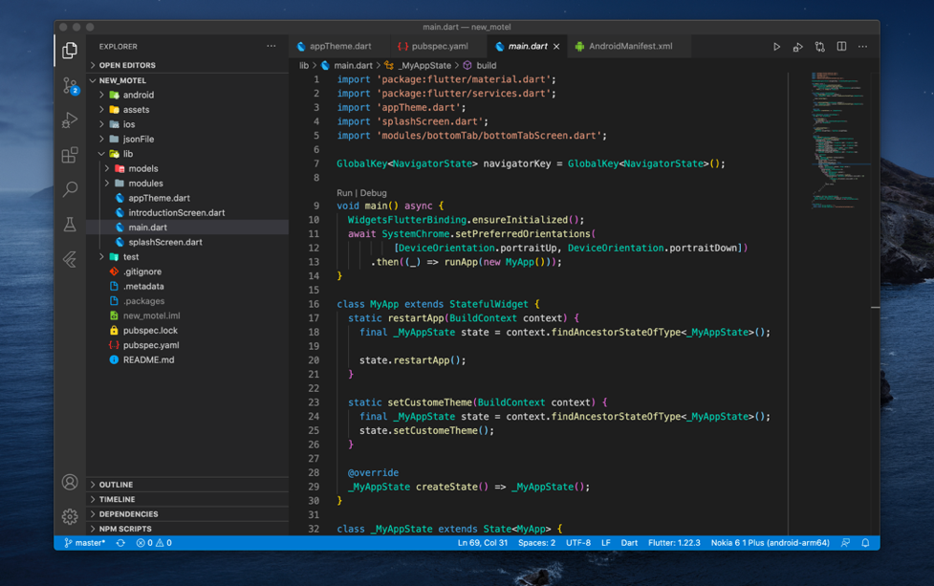

After you just goto pubspec.yaml then click on get-packages arrow button

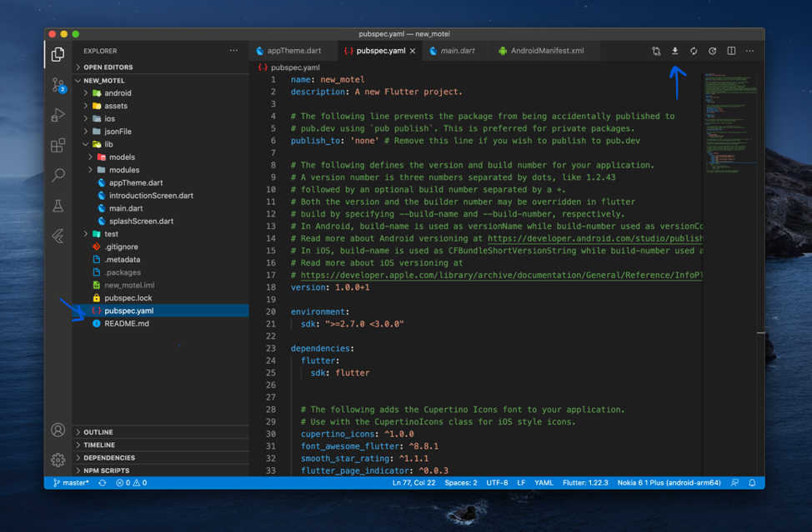

**Step 4:**

You need to add google map key for ios and android, you can see here. First image for android, and second one is ios.

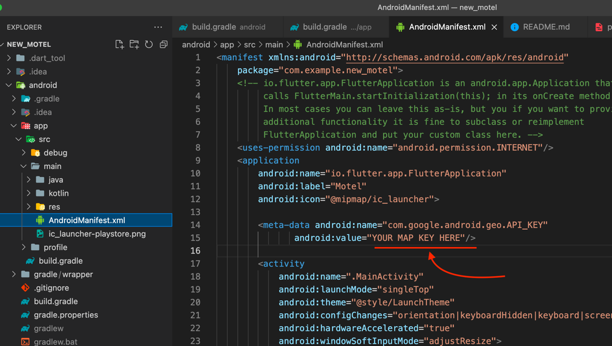

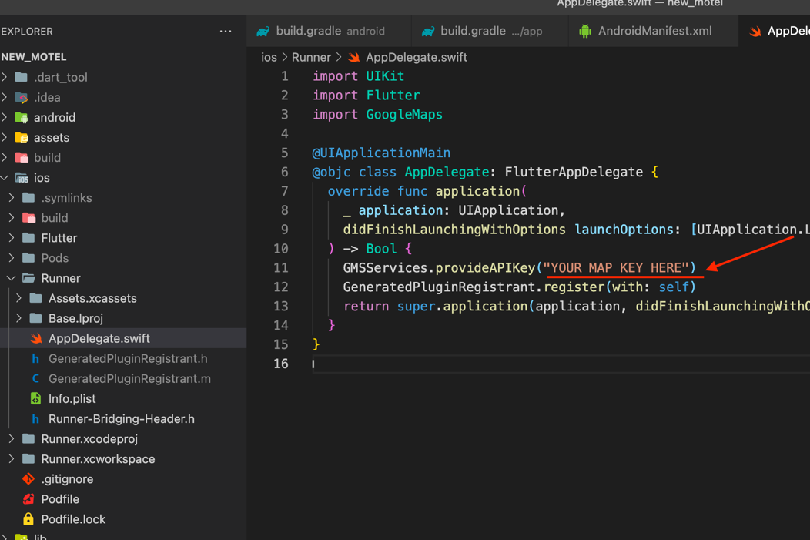

finally you done all thing just run project for click start Debuggin.

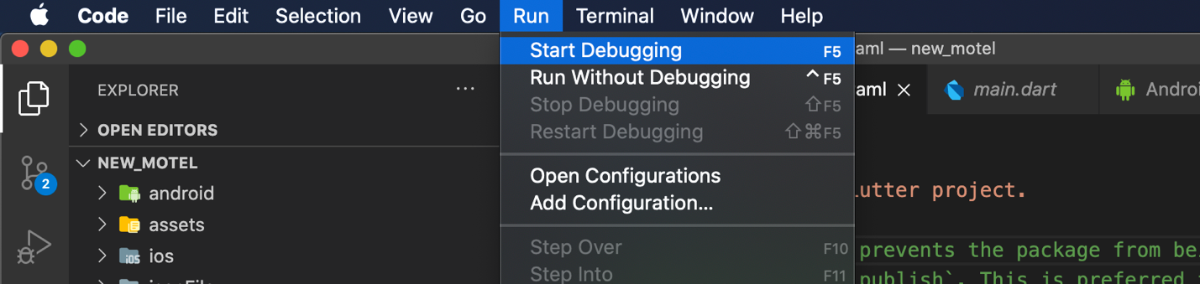

**Basic Project Structure:**

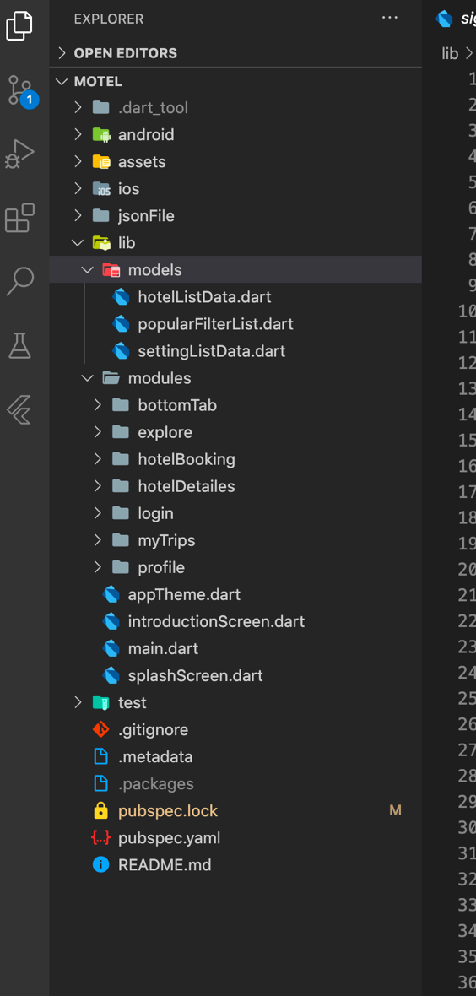

You can see the lib folder this our project all coding stuff,

**Models:** we store all data models.

**Modules:** we store all modules like all screen, home, booking screen etc, you also check this all screen UI is separated in folders so you can understand this all code easily.

**Follow dart file:** main.dart => splashScreen.dart => introductionScreen.dart => etc…, so you can understand the code.

**Description:**

* will give all most all the details required for a hotel booking application which includes personal detail, room images, animosities details, etc. Everything was made with a detail-oriented style and followed by today’s web trends. Clean coded & Layers are well-organized, carefully named, and grouped.
* Change text, colours, and graphics, add or place photos. Customize every element as much, or as little as you want. Customize elements (easy to edit)
* 100% free fonts Perfect pixel (high-quality design) Very clean and cool UI Free updates.

**Hotel Booking flutter UI Kit Features:**

* Supported mobile android and iPhone
* Dart Language
* UI/UX design from industry experts
* Smooth Transition Effects
* Font Awesome & Material Icons
* Work Sans Font
* Mobile and Tablet Support
* Responsive design for all device
* Animation Controller
* Black & White Theme
* Complete hotels booking module
* Sign in, sign up, reset the password, setting profile
* 100+ Widget added with animations.

**How to edit & used project:**

You have good basic flutter level then you add easily without any problem, not then follow flutter cook book : <https://flutter.dev/docs/cookbook> this one the best material from flutter team.

Overall you can change anything and also you can copy class and past on other project if you need and used it any.